1. 測試內容：

DGS-3630為基於OFDPA實作之交換機，應具有多個openflow table，本測試為查看 DGS-3630 中table個數。

1. 測試環境架構：

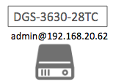

1. 測試環境組態：

* SDN controller: ONOS 1.15.0
* Switch: DGS-3630
* Apps:

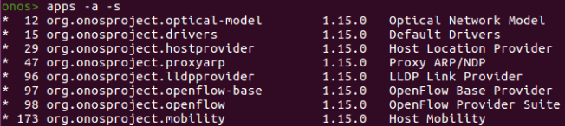

1. 測試步驟：
2. Switch CLI:

* Switch Firmware: 2.22.B007

|  |
| --- |
| Switch# show version |

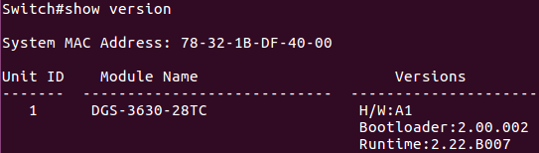

* The openflow status command shows the switch only support only one table.

|  |
| --- |
| Switch# show openflow status |

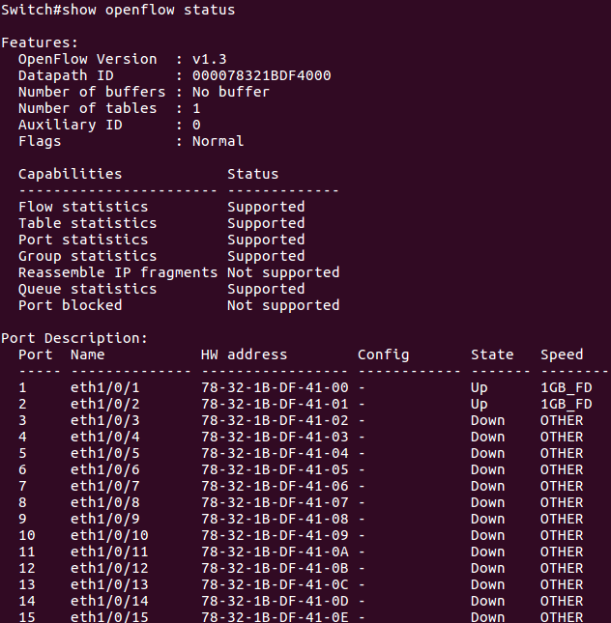

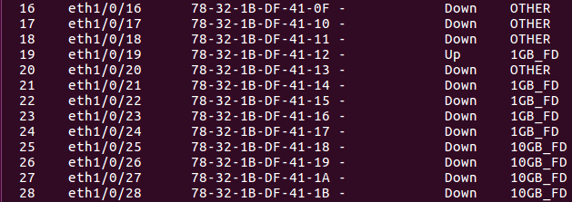

* The only id of table is 0.

|  |
| --- |
| Switch# show openflow table |

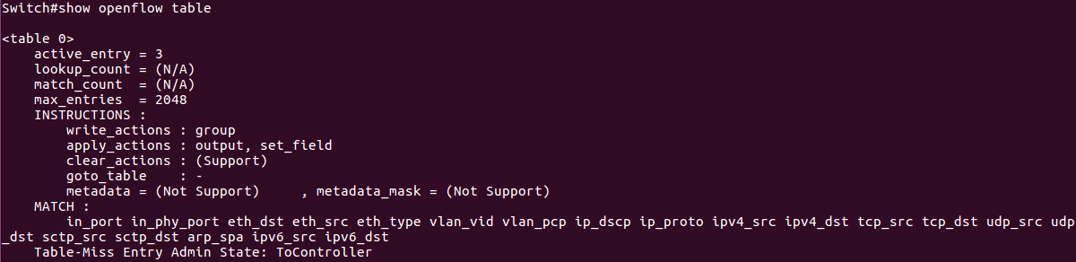

|  |
| --- |
| Switch# debug openflow flow-add table ? |



* If using a non-zero id of the table, the switch CLI would display error message

|  |
| --- |
| Switch# debug openflow flow-add table 1 idle-timeout 29 |



1. 測試結果：

DGS-3630 之Table個數只有一個且Table ID = 0。